NATIONAL SERVICE SCHEME
MANAGEMENT TEAM 202425


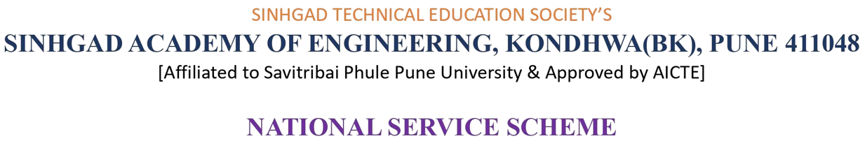

DATE: 15/0
4/2025

SR.NO. | VOLUNTEER’S NAME | POST
1. | ROHIT DIXIT | PRESIDENT
2. | KHUSHI | LADIES REPRESENTATIVE
3. | BHAVYA SACHDEVA | VICE-PRSEDENT & TREASURER
4. | YASH DESHPANDE | DIGITAL MEDIA HEAD
5. | VARADA KORLAHALLI | COMP. DEPARTMENT HEAD
6. | PRATIK LAHANE | IT DEPPARTMENT HEAD
7. | PRATIK KAKADE | E&TC DEPARTMENT HEAD
8. | MAYURI TAWDE | DOCUMENTATION HEAD
9. | SUJAL CHINCHMALATPURE | ATTENDANCE HEAD
10. | ADITYA BHADRE | ART & CULTURAL HEAD
11. | NIRANJAN KARCHE | MANAGEMENT MEMBER

Programme Officer Principal

